Date

FirstName LastName

Company

Street Address

City, State Zip

Dear FirstName:

On October 13-14, 2018, the brightest designers, developers, project managers, writers, and entrepreneurs will gather for AIGA Jacksonville’s Let’s Get Digital. The two-day design thinking and team-building workshop offer a deep dive into the design and research process in a collaborative and friendly atmosphere.   
  
Each year, AIGA Jacksonville partners with a local non-profit to give participants a chance to work on impactful, real-world problems. The workshop will take projects from a fast-paced ideation session to a prototype in a unique educational and inspirational experience.

Participants from every industry and facet in the community will also have the opportunity to acquire new skills, cultivate riveting discussions and thought processes, learn from each other, and engage on a social issue to enhance personal and professional development.

AIGA encourages supporting your employee’s desire to attend. We hope this is enough information to appreciate how tactical this developmental workshop will be. In short, attendees will become better designers and leaders. We are happy to answer any question.

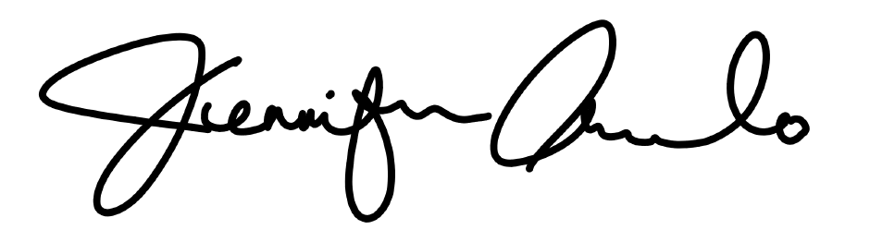Sincerely,

Jen Arevalo

President | AIGA Jacksonville

president@jacksonville.aiga.org